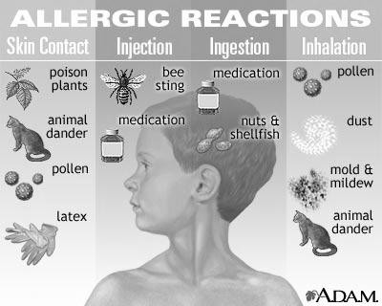
GREAT HEARTS ACADEMY – ALLERGY ACTION PLAN for the 2020/2021 SCHOOL YEAR

CHILD LAST NAME: FIRST NAME: DOB: PARENT/GUARDIAN: BEST CONTACT PHONE NUMBER: PHYSICIAN NAME: PHYSICIAN PHONE NUMBER: TEACHER: ROOM #

ALLERGIES:
TYPE OF REACTION: Anaphylaxis Nausea/Vomiting Rash
Other reaction: Allergic reaction may occur by: Ingestion Inhalation Touch or Other: Is the student asthmatic? yes no
My student will be eating food provided by local vendors for lunch yes no

My child may exhibit MILD symptoms with exposure to allergen Treatment of MILD symptoms include:
- Note time and occurrence of symptoms and stay with student
- Watch closely for any sign of a serious reaction
- Call parent/guardian listed above or communicate in writing of event
- Give the following Medication: Given to nurse yes date Dose: May repeat: Other instructions:
- Call 911 or give emergency medications if symptoms worsen

My child may exhibit SEVERE symptoms with exposure to allergen (Exhibiting any or all of the following symptoms is considered to be a severe allergic reaction: widespread hives and flushing, widespread tissue swelling, swelling of the tongue, throat itching or a sense of tightness in the throat, hoarseness and/or hacking cough, vomiting, nausea, cramps, diarrhea, repetitive coughing, wheezing, trouble breathing, rapid heart rate, lightheadedness, dizziness, loss of consciousness) Treatment of SEVERE symptoms include:
- Note time and occurrence of symptoms and stay with student
- Call 9-1-1 and inform them of a severe allergic reaction
- Administer according to package instructions(circle) EpiPen 0.3 mg intramuscularly Given to nurse yes
EpiPen Jr. 0.15 mg intramuscularly TwinJect 0.3 mg intramuscularly Twinject 0.15 mg intramuscularly
- Call parent/guardian listed above, continue monitoring student for return of severe symptoms
- Give injection device used, packaging, and student information to emergency responders
- Give the following ANTIHISTAMINE: Given to nurse yes date Dose: May repeat: Other instructions:

I understand that school staff MUST be informed of my child’s health concerns in order to provide safe and appropriate care. I will update the school nurse office as my child’s health conditions/treatments change throughout the year.

Parent/Guardian signature: Date:

Food Allergy Action Plan

Place Student's Picture Here
Emergency Care Plan

D.0.8.: _ , ,/'---

Allergy to:-------------------------

Weight: lbs. Asthma: 0 Yes (higher risk for a severe reaction) D No

Extremely ractive to the following foods :---------------------­ THEREFORlf:
0 If checked1 give epinephrine immediately for ANY symptoms if the allergen was likely eaten.
,
D If checked give epinephrine immediately if the allergen was definitely eaten, even if no symptoms are noted.

I
Any SEVERE SYMPTOMS after suspected or known ingestion:

One or more of the following:
LUNG: Short of breath, wheeze, repetitive cough HEART: Pale, blue, faint, weak pulse, dizzy,
confused
THROAT: Tight, hoarse, trouble breathing/swallowing MOUTH: Obstructive swelling (tongue and/or lips) SKIN: Many hives over body

Or combination of symptoms from different body areas: SKIN: Hives, itchy rashes, swelling (e.g., eyes, lips) GUT: Vomiting, diarrhea, crampy pain
1. INJECT EPINEPHRINE IMMEDIATELY
2. Call 911
- Begin monitoring (see box below)
- Give additional medications:*
-Antihistamine
-Inhaler (bronchodilator) if asthma

*Antihistamines & inhalers/bronchodilators are not to be depended upon to treat a severe reaction (anaphylaxis).USE EPINEPHRINE.

Medications/Doses

GIVE ANTIHISTAMINE
2. Stay with student; alert healthcare professionals and parent
MILD SYMPTOMS ONLY:
MOUTH:
SKIN: GUT:
Itchy mouth
A few hives around mouth/face, mild itch Mild nausea/discomfort
3. If symptoms progress (see above), USE EPINEPHRINE
4. Begin monitoring (see box below)

Epinephrine (brand and dose): Antihistamine (brand and dose):
Other (e.g., inhaler-bronchodilator if asthmatic): ----------------------

Monitoring
Stay with student; alert healthcare professionals and parent . Tell rescue squad epinephrine was given; request an ambulance with epinephrine. Note time when epinephrine was administered. A second dose of epinephrine can be given 5 minutes or more after the first if symptoms persist or recur. For a severe reaction, consider keeping student lying on back with legs raised. Treat student even if parents cannot be reached. See back/attacheq for auto-injection technique.

Parent/Guardia.n Signature Date
Physician/Healthcare Provider Signature
Date

TURN FORM OVER Form provided courtesy of the Food Allergy & Anaphylaxis Network (www.foodallergy.org) 9/2011

EPIPEN Auto-Injector and EPIPEN Jr Auto-Injector Directions
- First, remove the EPIPEN Auto-Injector from the plastic carrying case
- Pull off the blue safety release cap

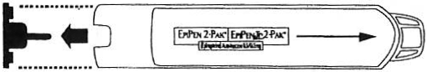
- Hold orange tip near outer thigh (always apply to thigh)

-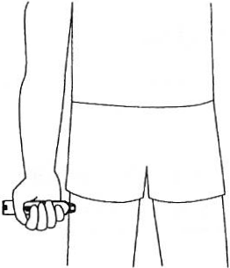
- Swingand firmly push orange tip
against outer thigh.Hold on thigh for approximately 10 seconds.
Remove the EPIPEN Auto-Injector and massage the area for 10 more seconds

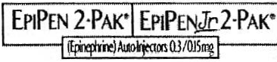
DEY" and !heDey logo, EplPcn",EplP•n 2.f>ak°,and Epil'tn Jr 2-Pak'art roglstcrtd
trJdem1riu of Dey Pharma,L.P.

Adrenaclick™ 0.3 mg and

Adrenaclick™ 0.15 mg Directions
.
-.
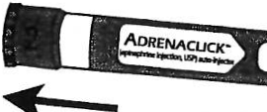 X 1Jm9

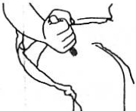
Remove GREY caps labeled
"1" and "2."

Place RED rounded tip against
outer thigh, press down hard until needle penetrates. Hold for 10 seconds, then remove.

A food allergy response kit sho!Jld contain at least two doses of epinephrine, other medications as noted by the student's physician, and a copy of this Food Allergy Action Plan.

A kit must accompany the stuc;tent if
- e/she is off school grounds {i.e., field trip).

Contacts
Call 911 (Rescue squad:(_) ------

Doctor:------- Phone: L_) __- _

Parent/Guardian:---------------------
Phone: L_) __- _

Other Emergency Contacts

Name/Relationship: ---- | --- | -------------­ | Phone: L_)-- | -- | -­
Name/Relationship:---- | --- | -------------- | Phone: L_) | -- | --

Form provided courtesy of the Food Allergy & Anaphylaxis Network (www.foodalleigv . org) 9/2011

